**Facial Recognition Door Unlock**

***A***

***Project Report***

***For Minor 02***

*submitted in partial fulfillment of the*

*requirements for the award of the degree of*

**BACHELOR OF TECHNOLOGY**

**in**

**COMPUTER SCIENCE & ENGINEERING**

**By**

|  |  |  |
| --- | --- | --- |
| **Specialization** | **SAP ID** | **Name** |
| DevOps | 500069424 | Rajul Dubey |
| DevOps | 500069565 | Devesh Yadav |
| DevOps | 500070100 | Karan Sharma |
| DevOps | 500067485 | Shriyansh Kaushik |

***Under the guidance of***

**Mr. Pushpendra Rajput**

Assistant Professor

Cybernetics Cluster

School of Computer Science



Department of Informatics

School Of Computer Science

UNIVERSITY OF PETROLEUM & ENERGY STUDIES,



**CANDIDATE’S DECLARATION**

I/We hereby certify that the project work entitled **“ <Facial Recognition Door Unlock System.>”** in partial fulfilment of the requirements for the award of the Degree of BACHELOR OF TECHNOLOGY in COMPUTER SCIENCE AND ENGINEERING with specialization in <Development and Operations and submitted to the Department of Cybernetics Cluster School of Computer Science, University of Petroleum & Energy Studies, Dehradun, is an authentic record of my/ our work carried out during a period from **<February>**, **<2022>** to **<May>**, **<2022>** under the supervision of **< Mr. Pushpendra Rajput Assistant Professor >**.

The matter presented in this project has not been submitted by me/ us for the award of any other degree of this or any other University.

This is to certify that the above statement made by the candidates are correct to the best of my knowledge.

Signature

**Mr.PushpendraRajput**

Project Mentor

DEHRADUN- 248007. Uttarakhand

Table of Contents

|  |  |  |
| --- | --- | --- |
| **Topic** | | **Page No** |
| Table of Content | | 2 |
| Revision History | | 3 |
| 0 | Abstract | 4 |
| 1 | Introduction | 4 |
|  | 1.1 Purpose of the Project | 4 |
|  | 1.2 Target Beneficiary | 4 |
|  | 1.3 Project Scope | 5 |
|  |  |  |
| 2 | Project Description | 5 |
|  | 2.1 Reference Algorithm | 5 |
|  | 2.2 Data/ Data structure | 5 |
|  | 2.3 SWOT Analysis | 6 |
|  | 2.4 Project Features | 6 |
|  | 2.6 Design and Implementation Constraints | 7 |
|  | 2.7 Design diagrams | 8 |
| 3 | System Requirements | 9 |
|  | 3.1 User Interface | 9 |
|  | 3.2 Software Requirements | 9 |
|  | 3.3 Hardware Requirements | 9 |
| 4 | Working |  |
|  | 4.1 Circuit |  |
|  | 4.2 Separation of modules |  |
|  | 4.3 Working of modules |  |
| 5 | Non-functional Requirements |  |
| 6 | Output | 9 |
| 6 | References | 10 |
|  | |  |

**Revision History**

|  |  |  |  |
| --- | --- | --- | --- |
| **Date** | **Change** | **Reason for Changes** | **Mentor Signature** |
|  |  |  |  |
|  |  |  |  |
|  |  |  |  |
|  |  |  |  |

**ABSTRACT:**

Door security plays of vital role in everyplace privacy. People often forget to lock their door when they went out which can lead them to a great cost. Any person can break-in and rob the house , for such problem facial recognition wins over. The main objective of this project is to develop a Facial Recognition Door Unlock System. Challenges detection face through system for face facial like recognition expressions, change in hairstyles, the presence of some object or intensity of light can be tackled[1].

**Keywords**—Face Recognition; Door Unlock System; Accuracy.

**1.INTRODUCTION:**

Now-a-days with the extreme use of smart devices are used to automate many of the processes. Home automation is one of the aggressively developed technology use by high end society. It's far tough to consider blindly on traditional and simple security features of the device. in conventional gadget many of the doors are having mechanical lock which have been constrained on the number of keys.[2] So, to overcome the aforementioned issues and traditional locking system one has to modify them and make them smart and automated. It works well but when we wish more secured environment and accountability of who locked and unlocked when is the major part was missing in traditional system[3].

This paper proposes Smart Door Unlock System based on Face Detection to enrich the security. Machine learning based approach with Haar Cascade method is in the project. In this system camera sensor will be used to capture the face and image matching algorithm will be used to detect the authenticated faces. Only the person whose face is matched can be able to unlock the door.p[4] So, limitation of dealing with keys will be resolved. This system will now not best beautify the safety however additionally make the device keyless. Many promising digital based automated solutions came in market whose detailed analysis is given in literature survey, a few are thumb based, Iris based and Face Based.[5] Many people tried to develop the automation on door based on smart cands,thumb based, iris based but very few of them are prominent for face based solution [6].

This system is so promising but has its own pros and cons. Certain challenges are also faced when we use face detection such as lightening, varying brightness. The main advantage of this system is acquiring the door using face detection approach and entire face is recognized. Face recognition technique involves attribute extraction from facial image with help of smart door face recognition model an intense innocence is expected in security industry and to make daily objects synergistic[7].

**1.1 Purpose of the Project:**

When it comes to securing the shield of our house - the door - we must wisely choose a lock that does not compromise safety. In this technologically advanced age, upgrading ourselves from traditional mechanical locks to smart locks has become crucial[5]. Today's digital door locks can come in handy, as they offer excellent features that can help you enhance and customize the security of your home as per your needs. One of these unique advantages that come with modern locks is Face Recognition Technology[8].

**1.2 Target Beneficiary:**

**1.Less Time-Consuming -**While using a simple lock and key system, a lot of time is consumed in taking out the keys from your bag, inserting it inside the cavity of the lock, and then unlocking the door.[9] However, using the face recognition feature offered by digital locks takes no more than a fraction of a second to open the door. The user is thus facilitated with a seamless experience[10].

**2.Say Goodbye to Physical Keys** - A key is an important object that is required to be handled with care and losing it becomes a matter of concern. Moreover, creating and distributing multiple copies of the key among your family members adds to the worry of misplacing them. Hafele’s Digital locks provide the user with the capacity to store more than 100 unique accesses. As a result, you and your entire family will be able to unlock and enter the door conveniently[11].

**3.No Contact Needed** - During the ongoing COVID pandemic, we need to protect ourselves by avoiding excessive contact with surfaces and objects, as this may lead to the possibility of contracting the virus. Thus, installing digital door locks with a face recognition feature in your home or office can ensure a more safe and sanitary experience[11].

**4.Highly Secure** - While a pin or password could be misused by someone who may have seen it, face recognition is a powerful feature that accurately identifies the person's face and their expression to unlock the door. Hafele's [Re-Veal digital lock](https://digital-locks.hafeleindia.co.in/re-veal-digital-door-lock) can scan over 170 facial points. This ensures that your home is completely secure. Moreover, it has the ability to distinguish between a real human face and an image or a video[12].

**5.Old Age** - Although fingerprints do not change with age, it can be more difficult to capture them in older people[12]. This is because the skin loses elasticity with age, and the patterns become less prominent, especially due to the thickening of ridges and furrows. Facial recognition could be better in this case[13].

**1.3 Project Scope -** The In future, this system can be changed into double verification mechanism such as retina scanner, fingerprint scanner, OTP, PIN Code, etc. This system will first recognize the face and if face is found in the database then it will ask for second verification mechanism will may be any one of the above and if the person passes both the verification test then only door will open and if face is not found in the database the image will be sent to website. This system will provide excellent security[14]. The face recognition mechanism can be combined with any other.

**2.PROJECT DESCRIPTION:**

**2.1 Reference Algorithm**: The first task is to gather the data for which we are going to train our classifier. We will write a python code that will take 30 faces of each person using OpenCV pre-trained classifier. OpenCV already contains many pre-trained classifiers for face, eyes, smile, etc[15]. The classifier we are going to use will detect faces and the cascade file is available on GitHub. Save this file in the working directory as "haarcascade_frontalface_default.xml"[16].

**2.2 Characteristic of Data:** The image of the person will be captured by the camera at the entrance when a person enters the classroom. Then, extraction and pre-processing are done of the face region for further analysis. But only one or maximum two people can enter the classroom at the same time[18]. Since, it is a major drawback of the system, but face recognition has proven to be more efficient than other existing systems. When the dataset of the person’s face is created then it is fed to data training for extracting features for further processing.

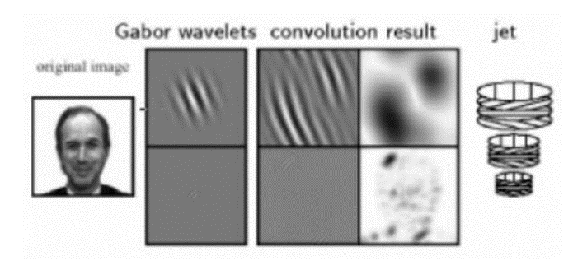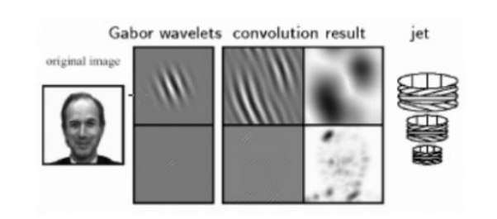

(a) Elastic Graph Representation

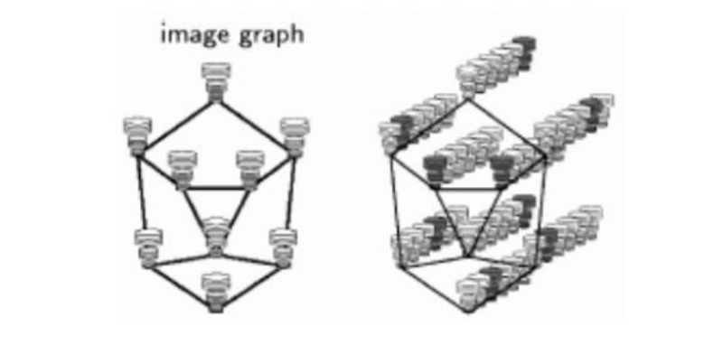

(b) Bunch Graph

**2.3 SWOT Analysis:** The following SWOT Analysis outlines the advantages and disadvantages a facial recognition door unlock system can bring[19].

|  |  |
| --- | --- |
| **STRENGTS** | **OPPORTUNITIES** |
| * It can be faster than other biometrics authentication methods. * There are lot of face detection algorithms and APIs online that help build such a system * It is easy to detect intruders. * Footage can be recorded to be manually checked. * It can detect other face details such as eye and hair. | * It can speed up the process of locking and unlocking doors * Face recognition systems are becoming more reliable and accurate * Such systems are easy to implement due to how advanced technology is. * It offers protection against intruders as they can be easily detected |

|  |  |
| --- | --- |
| **WEAKNESSES** | **THREATS** |
| * It is not as accurate as other biometrics authentication methods. * It depends on the distance and pose of the face as well as the quality illumination of the image/video used. * It is slow if it does not use a live video footage for recognition | * Other biometrics authentication methods can be more accurate * Intruders can be abuse the system by waring accessories to hide their identity. * It has to use a live video footage for recognition to be faster than other systems. |

**2.4 Project Features:** Face recognition is an advanced feature in digital locks where people can easily unlock the door using their faces. All you need to do is position your face in front of the lock, following which the camera scans it to check if it matches correctly with the pre-stored faceprints and then unlocks the door for you.

* Captures an image from the camera
* Detect human face from the given image
* Match the given face with the database
* If the face matches open the door
* Else keep in the previous state

**2.6 Design and Implementation Constraints:**

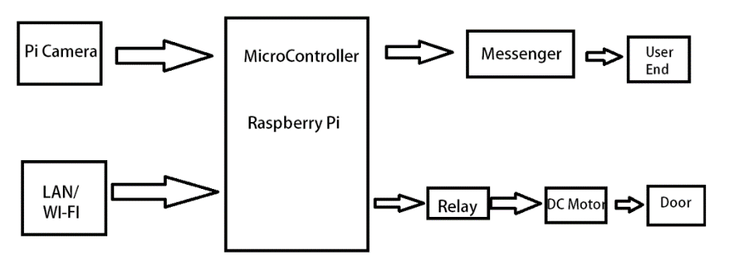

Figure1. The proposed system block diagram

Figure 1 show the block diagram which have Pi Camera, LED's, DC Motor, Raspberry Pi3

Module of the system will be connected to the door. as the user approaches the door The camera on fixed on that door (Pi Camera) captures the images.

After capturing the image Haar CasCade comes into action and detect the face whcih was captured through the video input door camera [8]. We will use pre-trained version of Haar-cascades with the help of OpenCV libraries so that we don't have to train it to detect whether it is a face or not. The important thing about cascades is that calculation speed and the accuracy. If there’s a face which is clear are nothing but positive values Haar classfies the images in positive and negative images if there’s a face detected it is a positive image otherwise it is negative[9]. Adaboost machine learning algorithm is used to avoid the complexity of calculations, which is inbuilt in Open CV library [10]. After the detection of the face Raspberry Pi process the captured image coordinates with existing coordinates int the database with the use of PCA(Principal Component Analysis) If it matches then it will send signals to Pi relay throu GPIO pins which will driver the DC motors which will unlock the door.

**2.7 Design diagrams:**

**1. Use Case Diagram:**

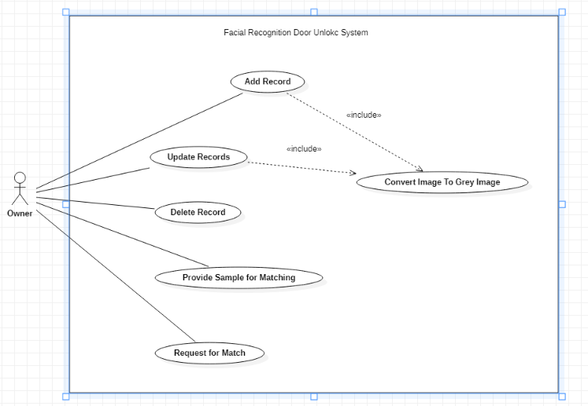

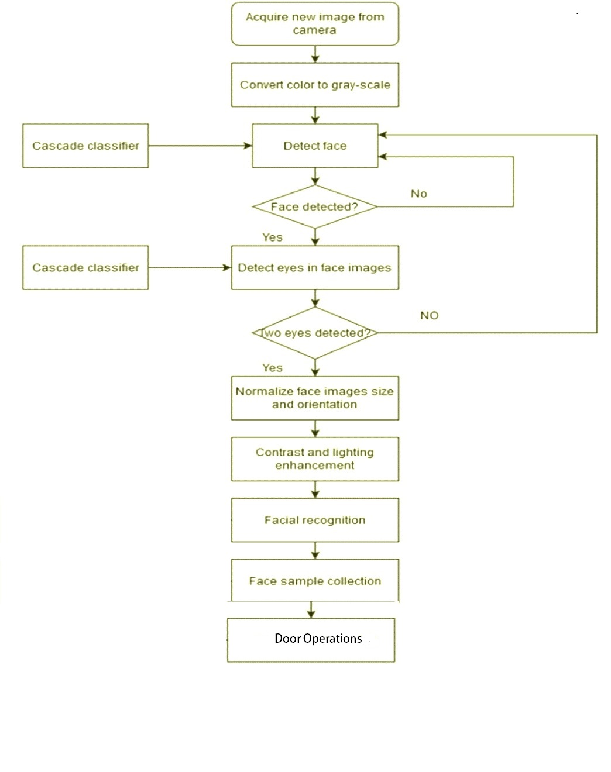**2. Activity Diagram:**

**3. SYSTEM REQUIREMENTS:**

**3.1 User Interface:**

* Small Pi LCD screen for to switch the lock into input mode

**3.2 Hardware Requirements:**

* Raspberry Pi:

The version of the model (A or B) doesn’t really matter. But we have used Raspberry Pi model B with Wi-Fi. With the intention of promoting the teaching of basic computer UK has developed Raspberry Pi as a credit card sized single board. It has a Broad com system on a chip (BCM2835). It also includes an ARM11 700 MHz, video core IV GPU, with originally 256 MB of RAM, now upgraded to 512 MB. It uses SD card for long term storage purpose. It uses a 5V power supply to run [11].

* Pi Camera:

It comes with a flex cable. This is inserted into the connector located in between the Ethernet and HDMI port. When there is someone next to the door, by using face recognition software it can capture the image and store it in the database using python and then it can be send to the owner through android application, this can help in providing security to home. The camera is capable of 2592 x 1944- pixel static images, and supports 1080p30, 720p60 and 640x480p60/90 video.

* Relay:

In our system we have used two channel relay for device control. A relay is an electrically operated switch to operate a suitable pull in and a holding current should be passed through its coil. It is designed to operate from 5V to 12V. Relay would be ON, When a LOGIC 1 is written on th e port PIN. It is turned OFF by writing LOGIC 0 on the port pin. The main advantage of this is it very low cost and expandable, and it is noise free system.

* DC Motor:

A DC motor is rotary electrical equipment which converts electrical energy into mechanical energy. A current running through a coil of wire generates an electromagnetic field aligned with the center of the coil. Changing of the direction and the magnitude of the magnetic field can be done by changing the current flow through it. It is connected to the relay where it drives the miniature door after successful recognition process.

**3.3 Software Requirements:**

* Python 3
* OpenCV-contrib-python
* Numpy
* Pycharm IDE (For testing purpose)
* Haar Cascade (Library for face detection)
* Pyserial (For serial input output)
* Pyttsx3

**4. Working**

**4.1 Circuits**

The circuit Diagram is given below .The Servo Motor Signal Pin will be Connected to the arduino Pwm Pin Number 9. The 5V pin will be connected to Arduino 5v pin and Ground pin will be connected to Arduino Ground pin. Arduino must be connected to Pc through arduino Cable.

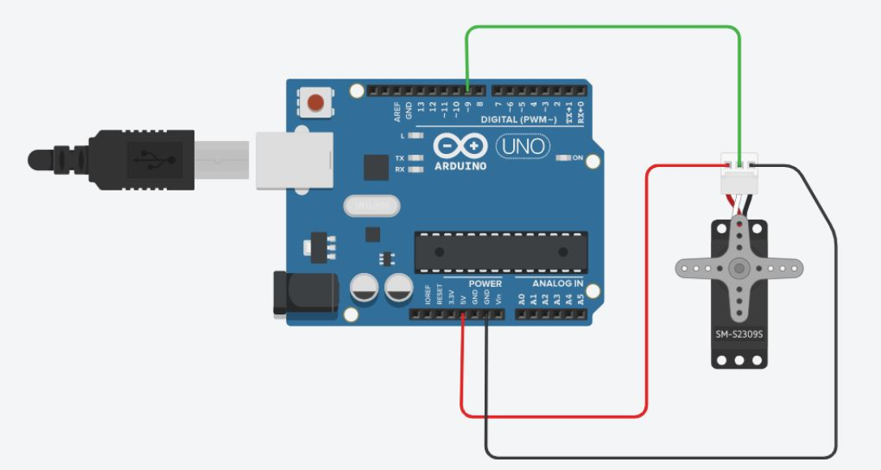

At first the python code will be write on any of the python IDE than arduino code will be uploaded to arduino Uno board using arduino IDE and then Run the 1st python code it will collect the sample pictures and then run 2nd code and it will start the webcam and take pictures , if the picture match with database upto 83% then it will send a charecter to the arduino and arduino will move the servo motor for 5 seconds.

**4.2 Separation of Modules**

We have separated out source code into 3 modules:

**1. GUI:** This module provides basic interface between other modules of the software

**2.** **Data Collection:** this module is used to collect the data input(face sample) from the user to train the model for unlocking mechanism

**3. Locking System:** This module train itself from the data base which we gathered using Data Collection and perform action accordingly

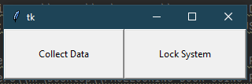

**4. Deploying the code:** In this phase we deploy the configuration code for Arduino written in C language

**4.3 Working of modules:**

**4.3.1Data Collection Module:**

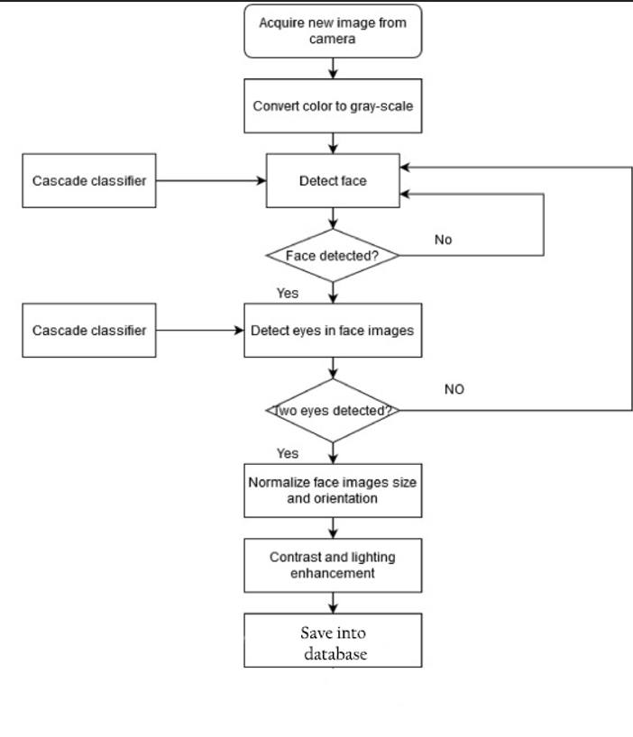

**4.3.2 Lock System Module:**

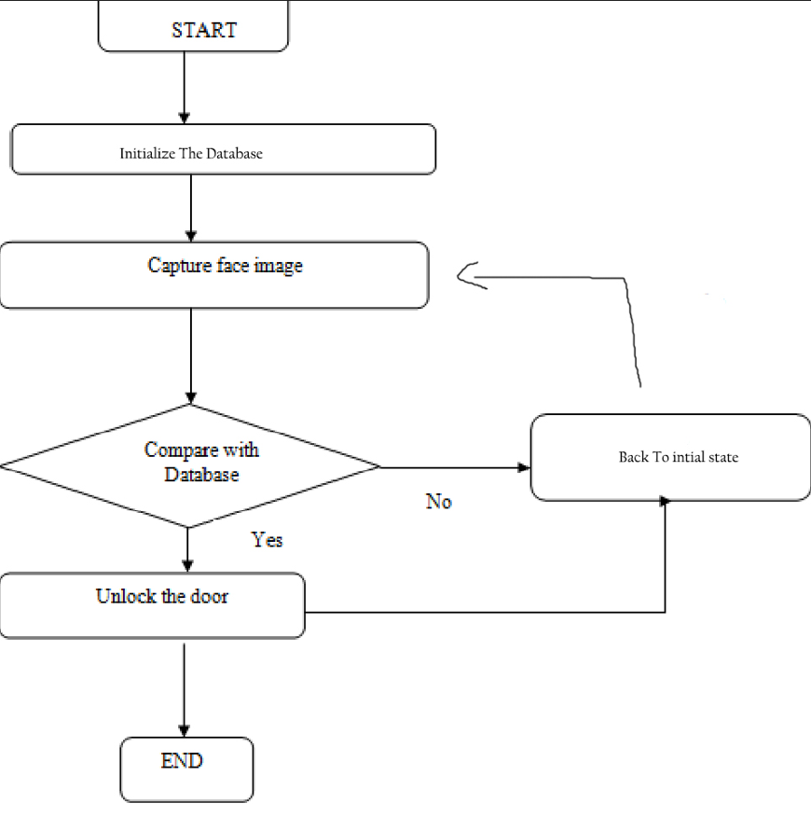

**5. Non-functional Requirements:**

* Continuous supply of the electricity is required for the system to work.

**References:**

[1] Nadafa, Raju A., et al. “Home Security against Human Intrusion Using Raspberry Pi.” Procedia

Computer Science, 167, 2020, pp. 181120. DOI. or (Crossref), doi: 10.016/ j.procs. 2020.03.200

[2] Abaya, Wilson Feipeng, et al. “Low Cost Smart Security Camera with Night Vision Capability Using Raspberry Pi and Open CV.” 2014 International Conference on Humanoid, Nanotechnology, Information Technology, Communication and Control, Environment and Management

(HNICEM), IEEE, 2014, pp.1–6, DOI: 10.1109/HNICEM.2014.7016253.

[3] P. Bhatia, S. Rajput, S. Pathak and S. Prasad, "IOT based facial recognition system for home Security using LBPH algorithm," 2018 3rd International Conference on Inventive Computation Technologies (ICICT), Coimbatore, India, 2018, pp. 191-193, doi: 10.1109/ICICT43934.2018.9034420.

[4] S. Mathew, A. Sreeshma, T. A. Jaison, V. Pradeep and S. S. Jabarani, "Eye Movement Based Cursor Control and Home Automation for Disabled People," 2019 International Conference on Communication and Electronics Systems (ICCES), Coimbatore, India, pp. 1422-1426, Doi: 10.1109/ICCES45898.2019.9002325.

[5] Aishwarya D, Dr. J Arokia Renjith Enhanced Home Security Using IOT and Raspberry Pi.

[6] M.Nandini, P.Bhargavi, G.Raja Sekhar Face Recognition Using Neural Networks.

[7] Mohammadjaved R. Mulla; Rohita P. Patil; S. K. Shah 2015.Facial Image Based Security

System using PCA.

[8] I. Aydin and N. A. Othman, "A new IoT combined face detection of people by using computer

Vision for security application," International Artificial Intelligence and Data Processing Symposium (IDAP), Malatya, 2017, pp. 1-6, doi:

10.1109/IDAP.2017.8090171.

[9] Sourav Roy; Md Nasir Uddin; Md Zahirul Haque; Md Jahidul Kabir, “Design and Implementation of the Smart Door Lock System with Face Recognition Method

Using the Linux Platform Raspberry Pi”, by IJCSN - International Journal of Computer Science and Network, 7(6), December 2018

[10] Neetu Saini, zukhwinder Kaur, Hari Singh, A Review: Face Detection Methods and

Algorithms, International Journal of Engineering Research & Technology (IJERT), ISSN: 2278-0181, 2 (6), June – 2013.

[11] Jhansi Rani G, Raghava Kumari D, Anitha M and Sarita B 2020 Analysis of raspberry pi-based ATM theft monitoring and security system International Journal of Psychosocial Rehabilitation, 24(8) 15376-15383 10.37200/IJPR/V24I8/PR281514

[12] Raghava Kumari D, Anitha M, Jhansi Rani G and Ramesh Babu D, 2020 Road traffic control by using Li-Fi technology between vehicle to vehicle communication International Journal of Psychosocial Rehabilitation, 24(8) 15393-15397 10.37200/IJPR/V24I8/PR281516

[13] Swathi N, Padmaja Ch and Navya Jyothi G 2020 Audio assistive for blind people to identify the cloth patterns and colors Journal of Critical Reviews, 7(17) 154-158 10.31838/jcr.07.17.23

[14] Mahender K, Kumar TA and Ramesh KS PAPR 2018 analysis of fifth generation multiple access waveforms for advanced wireless communication, International Journal of Engineering and Technology (UAE), 7(3.34 Special Issue 34) 487-490 10.2147/NBHIV.S68956_old.

[15] Bhushan, B., & Sahoo, G. (2018). Routing Protocols in Wireless Sensor Networks. Computational Intelligence in Sensor Networks Studies in Computational Intelligence,215-248. doi:10.1007/978-3-662-57277-1_10

[16] Zhao W., Chellappa R., Phillips P. J., and Rosenfeld A., Face recognition: A literature survey, ACM Computing Surverys (CSUR), 35(4), 2003, 399-458.

[17] Okada K., Steffans J., Maurer T., Hong H., Elagin E., Neven H.,

Andmalsburg C. V. D., (1998). The Bochum/USC Face Recognition System and how it fared in the FERET Phase III Test. In Face Recognition: From Theory to Applications, Eds. Springer-Verlag, Berlin, Germany, (1998) 186-205.

[18] Wiskott L., Fellous J.-M., and Von dermalsburg C., (1997), Face recognition by elastic bunch graph matching. IEEE Trans. Patt. Anal. Mach. Intell. 19, (1997) 775-779.

[19] Buhman J., Lades M., and Malsburg C. V. D., (1990), Size and distortion invariant object recognition by hierarchical graph matching. In Proceedings, International Joint Conference on Neural Networks. (1990) 411-416.